01.Ticket Rift Rock
Environment Specifics
Please be aware that every JS environment may behave differently when executing code. Certain things that work in the browser are not supported in Node.js, which is the environment used by Judge.
The following actions are NOT supported:
- .forEach() with NodeList (returned by querySelector() and querySelectorAll())
- .forEach() with HTMLCollection (returned by getElementsByClassName() and element.children)
- Using the spread-operator (...) to convert a NodeList into an array
- append() in Judge (use only appendChild())
- prepend()
- replaceWith()
- replaceAll()
- closest()
- replaceChildren()
- Always turn the collection into a JS array (forEach, forOf, et.)
If you want to perform these operations, you may use Array.from() to first convert the collection into an array.
Use the provided skeleton to solve this problem.
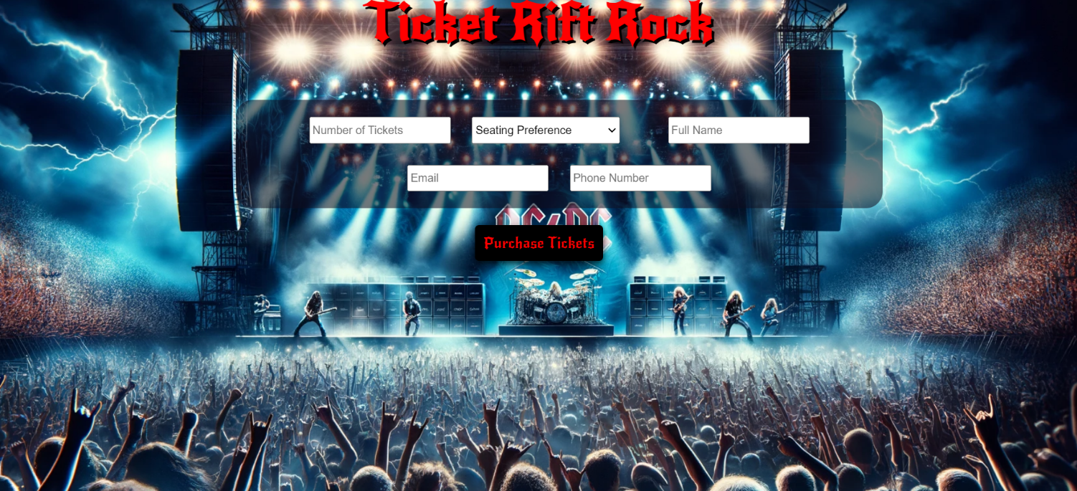
Write the missing functionality of this user interface. The functionality is divided in the following steps:

Your Task
Write the missing JavaScript code to make the Ticket Rift Rock work as expected:
All fields (Number of Tickets, Seating Preference, Full Name, Email, and Phone Number) are filled with the correct input
- Number of Tickets, Seating Preference, Full Name, Email, and Phone Number are non-empty strings. If any of them is empty, the program should not do anything.

1.Getting the information from the form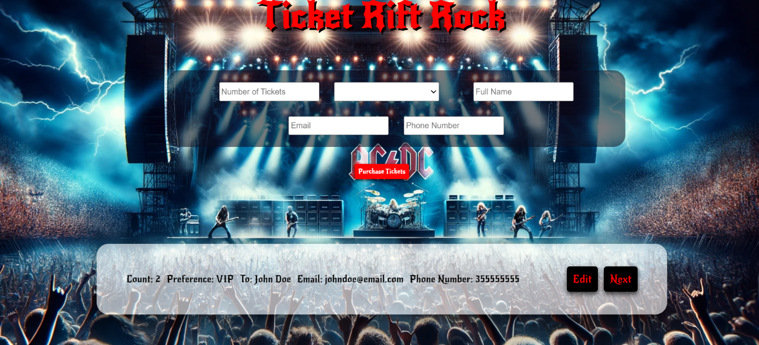
• When the ["Purchase Tickets"] button is clicked, the information from the input fields is listed in the unordered list. A list item is added to the " ticket-preview" unordered list.
- The list item should follow the same text format and order as shown in the provided picture.
- When the button is clicked, the input fields must be cleared, and the ["Purchase Tickets"] button should be disabled. Additionally, the "Edit" and "Next" buttons need to be added.
The HTML structure looks like this:
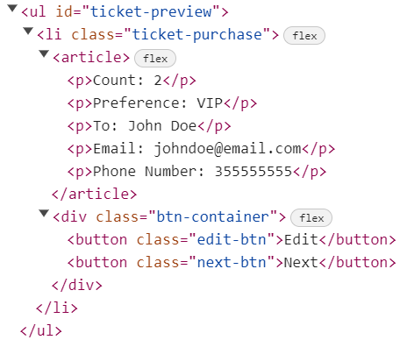

2.Edit Ticket Info

The functionality here is the following:
- When the "Edit" button is clicked, all of the information is loaded in to the input fields from step 1 and list item is removed while the ["Purchase Tickets"] button is enabled again.
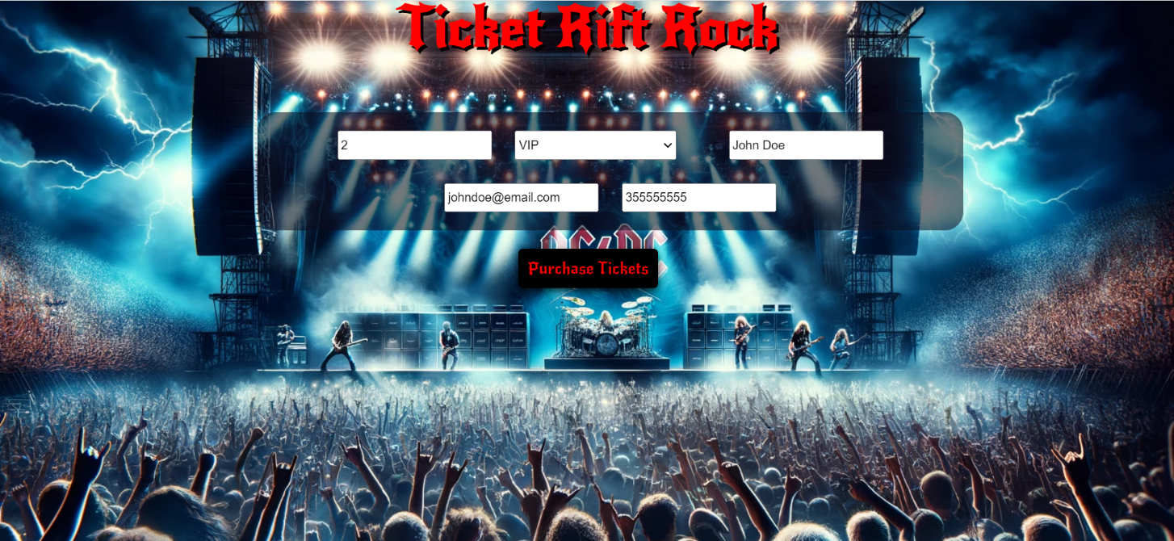
- The list items must be removed from the "ticket-preview"
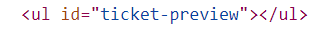

3.Next
- When the "Next" button is clicked, the information from "ticket-preview" unordered list must be transferred to "ticket-purchase". For you, this means removing everything inside of the <ul> with class = "ticket-preview" and adding in "ticket-purchase", the list item with same information The "Buy" button must be added.
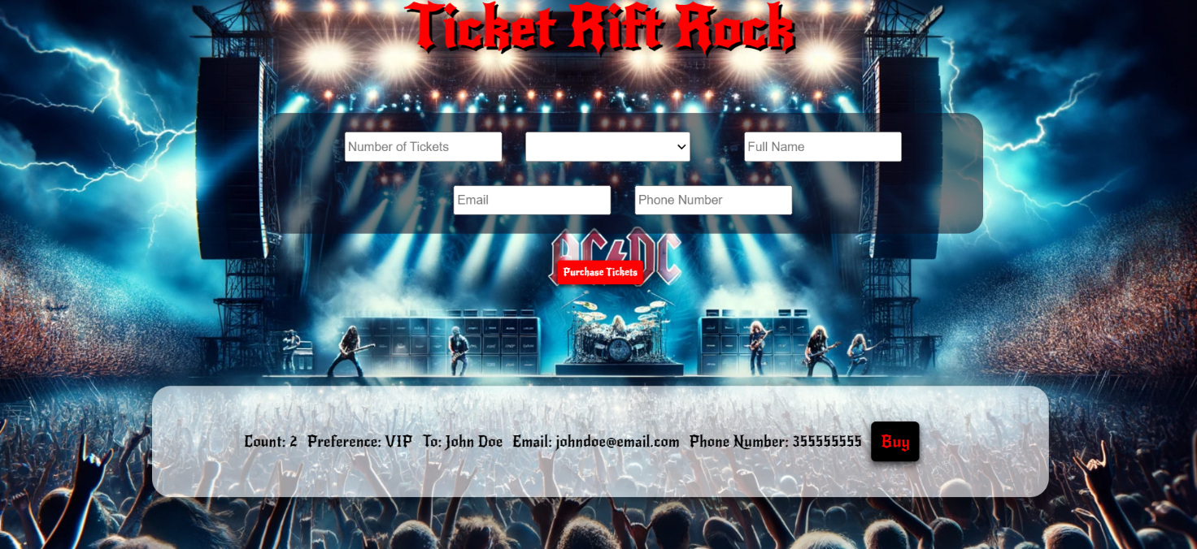

- This is the HTML structure of the "ticket-purchase" unordered list:
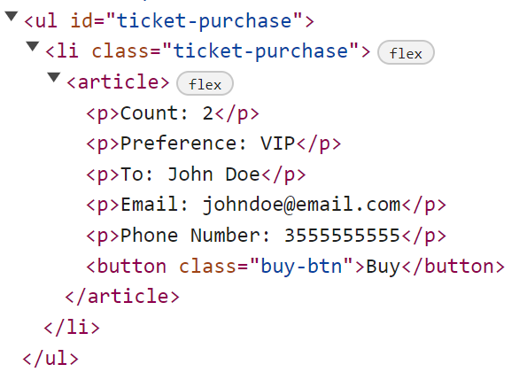

3.Buying

- When the "Buy" button is clicked, you must remove list item from "ticket-purchase" unordered list and then add h2 element with text "Thank you for your purchase! " and "Back" button
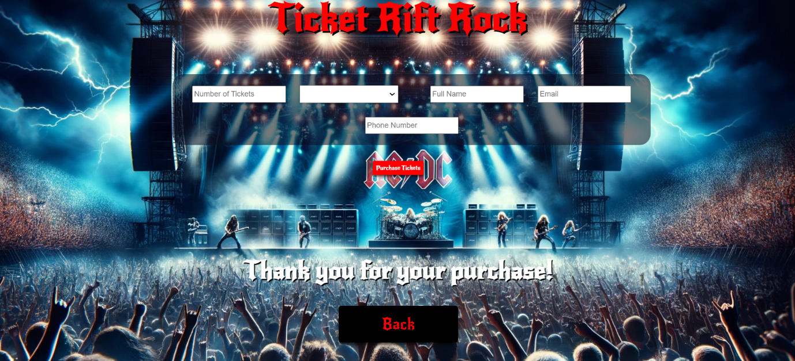
- This is the HTML structure:
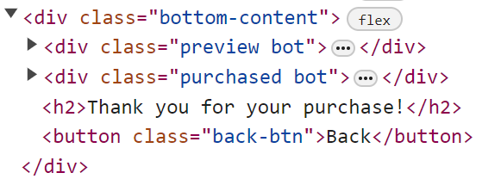

4.Back

- When the "Back" button is clicked, you must reload the page or remove h2 element with text "Thank you for your purchase! " and ["Back"] button while the ["Purchase Tickets"] button is enabled again.
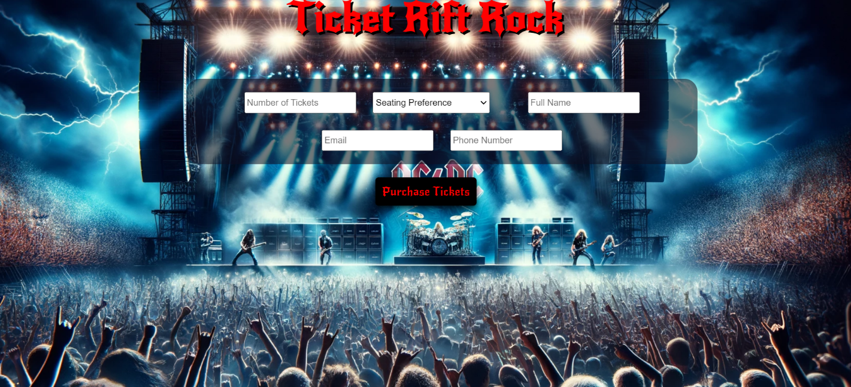

Submission
Submit only yours solve() function.

GOOD LUCK…

